The Fairview Elementary School
Production of
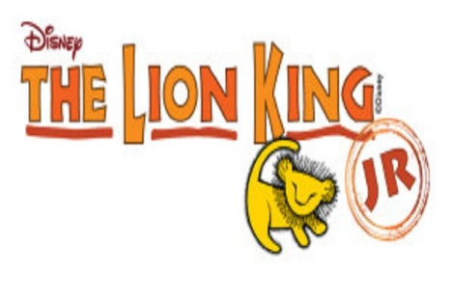
Thursday, 11/19/2015 and Friday, 11/20/2015
6:30pm
At Fairview Elementary School

Tickets are now on sale for Fairview’s production of The Lion King Jr! In order to defray the costs of our production, we are selling tickets for $8.00 per person. Children 2 and under are free (laps only).

To order tickets in advance, please fill out the form below and return it to school in an envelope marked “Lion King Jr. Tickets”. Checks should be made out to “Fairview PTO” or use exact change. The last day to send in ticket orders is Tuesday, November 17th. After this date tickets must be purchased at the door on the night of the performance, if the show is not sold out.

The tickets will be delivered to your child through the school. You should receive your tickets within 2 days of your order being received.

TICKET ORDERS WILL BE FILLED ON A FIRST COME FIRST SERVED BASIS!
NO TICKETS WILL BE HELD WITHOUT PAYMENT.

If you have any questions, email Allison Costigan at acostigan7@gmail.com

TICKET ORDER FORM
Child’s name _______________________________

Teacher _____________________________ Grade __________

Number of tickets @ $8 for Thursday, November 19, 2015 _________

Number of tickets @ $8 for Friday, November 20, 2015 ________

Total amount paid ________

