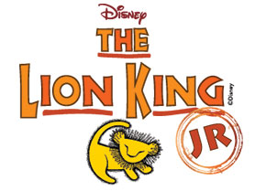Signature Video Productions, along with Fairview alumni parent John Craig, will be producing a DVD of Fairview Elementary School’s 2015 production of The Lion King Jr.

To pre-order your DVD, please fill out the form below and submit it in an envelope marked: DVD Sales – The Lion King Jr. Payment must be included with your order. Make checks payable to Fairview PTO.

The pre-order sale price is $15.00 per DVD and is available until November 16th. After November 16th, the price will increase to $20.00.

|  |  |  |  |
| --- | --- | --- | --- |
| QUANTITY | ORDER DATE | PRICE PER DVD | TOTAL |
|  | By: November 16th | $15.00 |  |
|  | After: November 16th | $20.00 |  |

Students Name:_____________________________________________

Teachers Name: ____________________________________________

Contact information: _________________________________________

(phone or email – in case there are any questions about your order)

Please contact Seegal Moses at [Sa3@aol.com](mailto:Sa3@aol.com) if you have any questions. Thank you.